Hands-on Exercises: Employee Management REST API using FastAPI Date: 19-10-26

from fastapi import FastAPI, HTTPException, status
from pydantic import BaseModel
from typing import List
app = FastAPI(title="Employee Management API")
class Employee(BaseModel):
id: int
name: str
department: str
designation: str
salary: float
city: str
employees: List[Employee] = []
@app.post("/employees", response_model=Employee, status_code=status.HTTP_201_CREATED)
def create_employee(employee: Employee):
# Check if employee ID already exists
for emp in employees:
if emp.id == employee.id:
raise HTTPException(
status_code=status.HTTP_400_BAD_REQUEST,
detail=f"Employee with ID {employee.id} already exists."
)
employees.append(employee)
return employee
@app.get("/employees", response_model=List[Employee])
def get_all_employees():
return employees
@app.get("/employees/{employee_id}", response_model=Employee)
def get_employee_by_id(employee_id: int):
for emp in employees:
if emp.id == employee_id:
return emp
raise HTTPException(
status_code=status.HTTP_404_NOT_FOUND,
detail=f"Employee with ID {employee_id} not found."
)
@app.put("/employees/{employee_id}", response_model=Employee)
def update_employee(employee_id: int, updated_employee: Employee):
for index, emp in enumerate(employees):
if emp.id == employee_id:
employees[index] = updated_employee
return updated_employee
raise HTTPException(
status_code=status.HTTP_404_NOT_FOUND,
detail=f"Employee with ID {employee_id} not found."
)
@app.delete("/employees/{employee_id}")
def delete_employee(employee_id: int):
for index, emp in enumerate(employees):
if emp.id == employee_id:
del employees[index]
return {"message": f"Employee with ID {employee_id} deleted successfully."}
raise HTTPException(
status_code=status.HTTP_404_NOT_FOUND,
detail=f"Employee with ID {employee_id} not found."
)

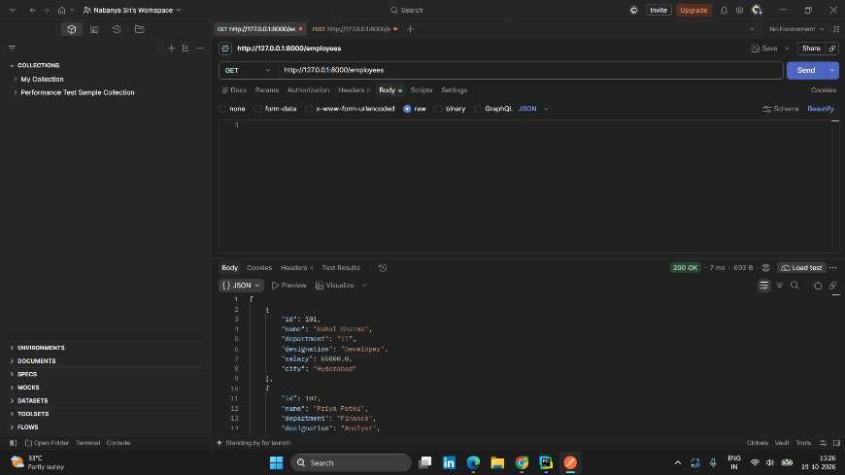
Exercise 1-3: Inserted records using POST and retrieved using GET

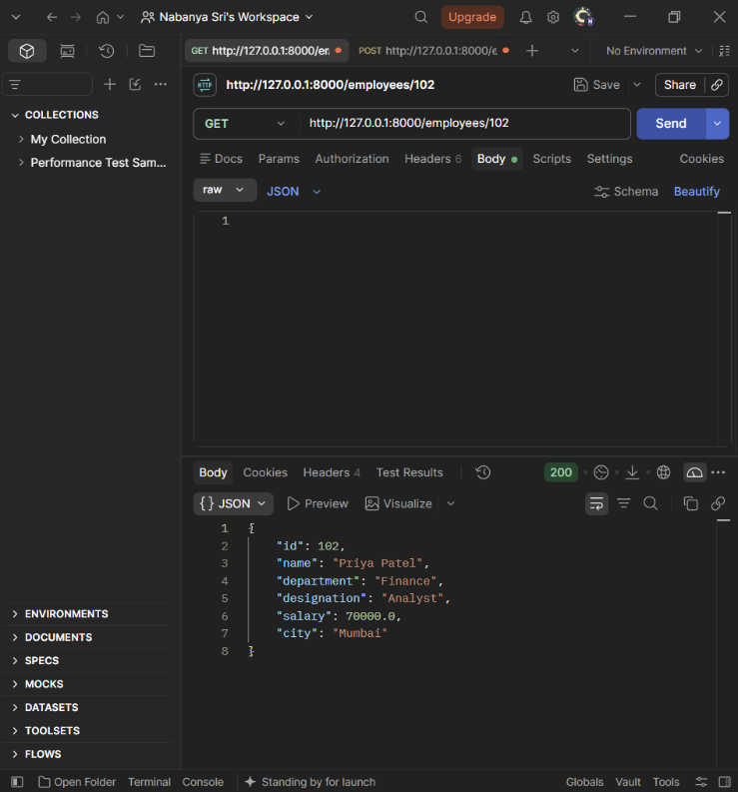
Exercise 4: Retreive Employee by ID
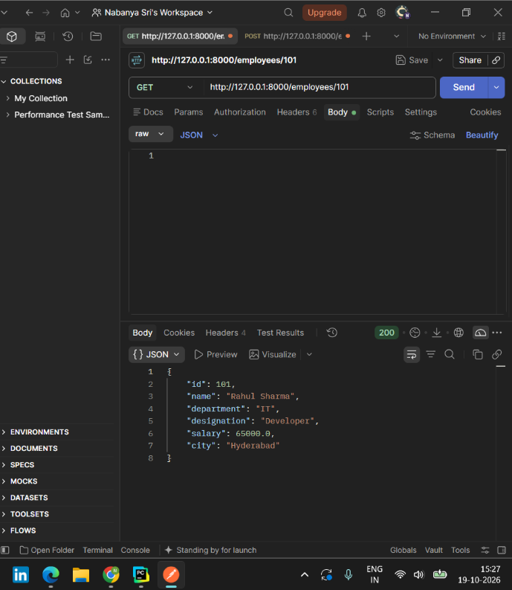
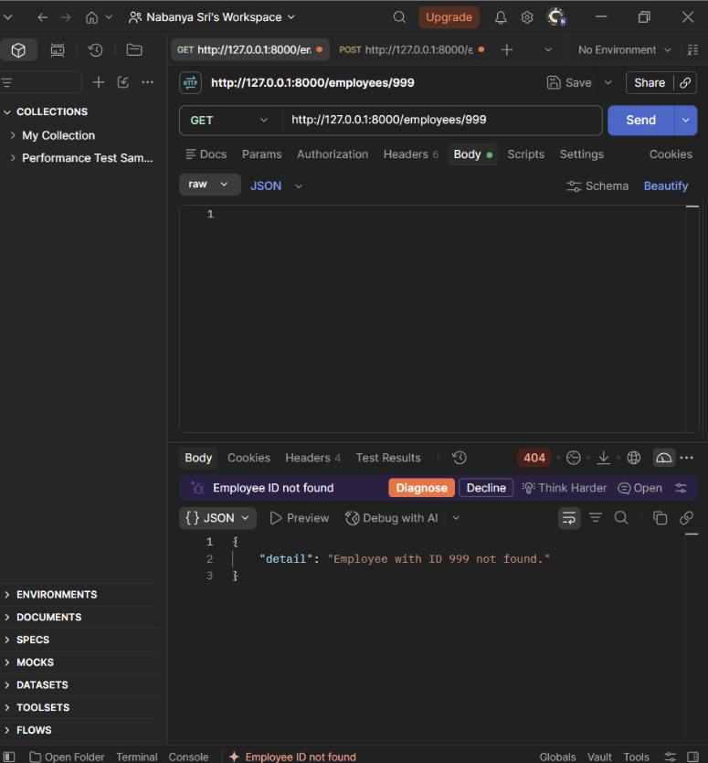

Exercise 5: Update Employee

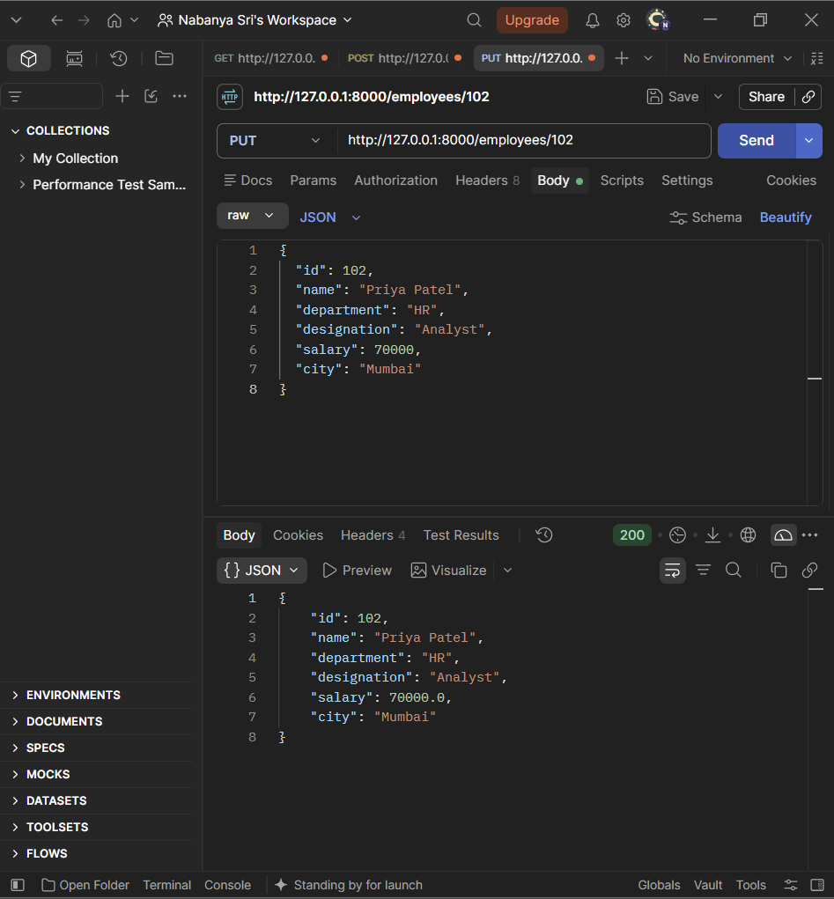
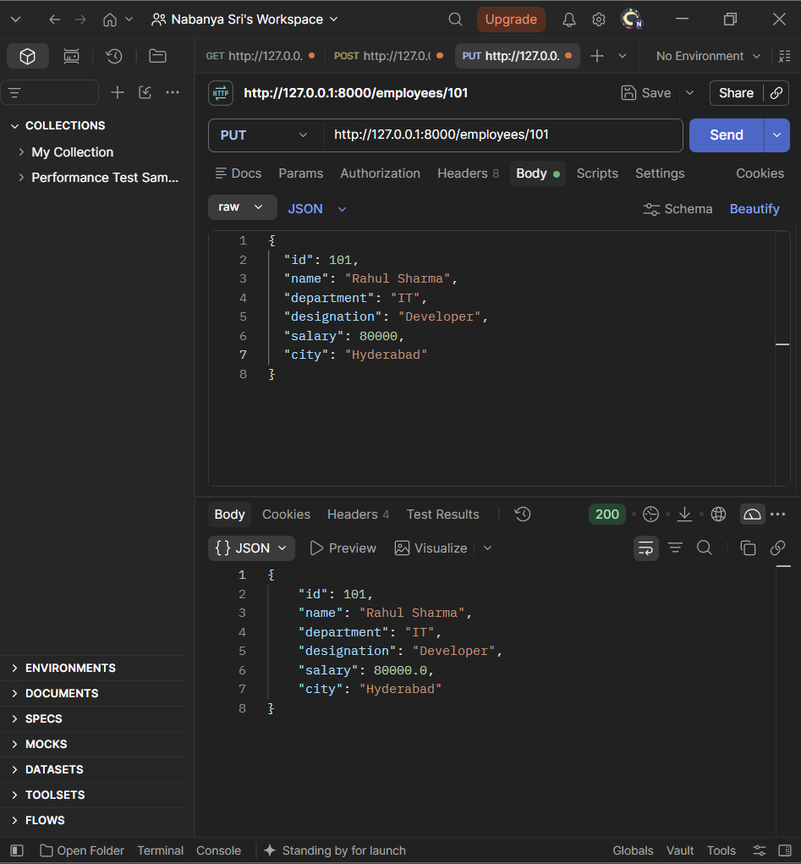
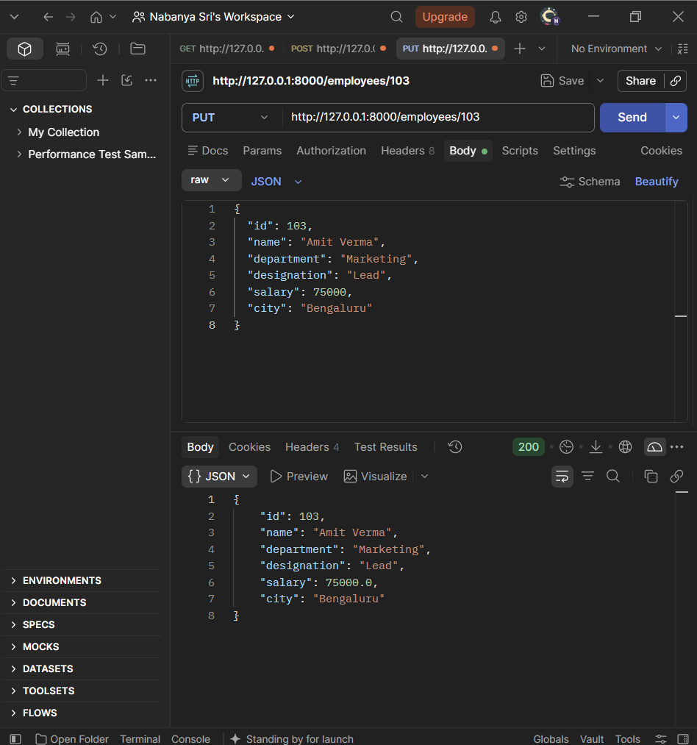

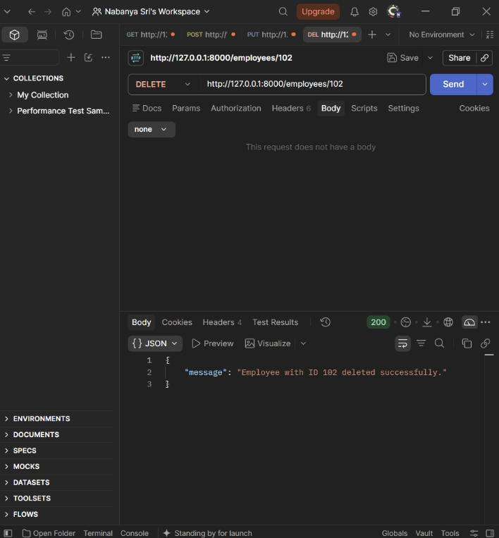
Exercise 6 : Delete Employee
